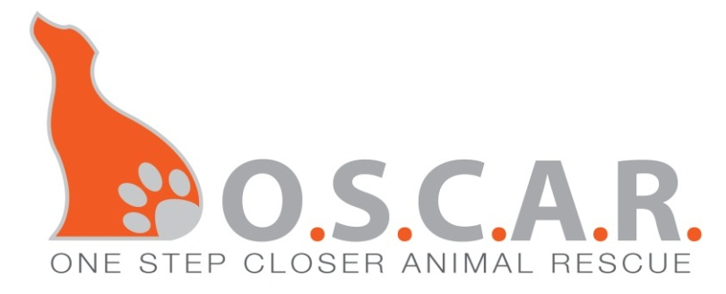
Adoption Application
If you are interested in adopting, please fill in your responses and email it to: OscarRescue@yahoo.com
or mail it to: OSCAR, PO Box 248, Sparta, NJ 07871

Our dogs/cats are not first come/first serve. We place our dogs/cats with the home that is the best fit for them. Not all animals are good in all homes, whether it’s their personalities, nature, or breed. We base our decision on what’s best for the dog/cat and the family. Thanks for understanding!

Adoption Fee is to be paid by Money Order or Cash—No Checks please.

NAME OF ANIMAL YOU WANT TO ADOPT: DOG(s)_______________ / CAT(s)_______________

Full name:__________________________________________________________ County:_________

Address:_________________________________ City:_______________ State:_____ ZIP:________

Home phone:_______________ Cell phone:_______________ E-mail:_________________________
_______________________________________________________________________________________
Name and phone number of the vet you have had within the last 10 years (Please call them ahead of time so they will know we are calling. If your vet has your dog/cat under your maiden name, please give us that name as well. Thanks.

______________________________________________________________________________________________________
Please list two personal references (name/phone number):
1.

2.
Place of employment: Hours a day you work:

How much time will the animal be left alone?

Are you planning on crate training?

Where will the dog/cat be kept at night? During the day?

Who else lives in the residence with you? (If any children, what are their ages?)

Does anyone in your home have dog or cat allergies?

Why did you choose him/her and how will you provide a good home?

When are you prepared to adopt the animal you are applying for?

Do you have any prior experience with dogs/cats?

_________________________________________________________________________________________
What problems would cause you to have to return this pet?

_________________________________________________________________________________________
Do you have any other pets currently? Yes No
If so please give their names & breeds?
Ages? Male? Female? Are they spayed/neutered?

Please describe their personalities.

Have you ever surrendered a pet to a shelter/pound? Please explain.

Is your family willing to allow time for the animal to adjust to its new home?

For Dogs: Are you planning on having their ears cropped (cut to stand straight up)? Yes No
For Dogs: Are you planning on having their tail docked (cut to leave very little tail left just a nub)? Yes No
If so, please explain?_________________________________________________________________________

For Cats: Are you planning on having the cat declawed? Yes No
If so, please explain?_________________________________________________________________________

Do you: _Own / _Rent _Home / _Condo / _Apartment _City / _Suburban / _Rural

If you rent, do you have permission from your landlord for a pet?_______________________________

If you have a condo, does your condo association permit you to have a pet?_______________________

Please provide landlord/condo association’s phone number:____________________________________

How long at this residence? What type of fencing if any?

Have you ever been in a situation where you re-homed a dog/cat, such as with a family member or friend? Please explain.

Please describe your household. (ie: active, quiet, noisy, energetic, etc.)

Who will be providing the majority of the care for this animal?

How did you hear about us?

Where will the animal stay while you are on vacation?

Are you aware that if for any reason you can no longer take care of the animal, he/she is to be returned to us? __Yes __No

Are you aware that if for any reason we deem that this animal is not being cared for properly that you will be required to return the dog/cat to us immediately? __Yes __No

O.S.C.A.R. will make every effort towards the adoption of the dog/cat I am requesting, pending my application approval, but I do understand that this application does not guarantee the adoption of the dog/cat that I am applying for. __Yes __No

Note: Adding a new member to your family is a big decision—a life-long commitment. Please discuss this decision with your entire family. We would like everyone to be excited about the new addition and not to be surprised when we call to set up a home visit. It would save us time that we could put into the animals, and you heart-ache in the long run. Thank you.

**Please remember puppies/kittens are not house-trained and require training and work.
They are a big responsibility. Please think about a puppy/kitten versus an adult dog/cat before adopting.**

Signature: _________________________________________ Date: ____________________________

